Create a trigger in MySQL to log the changes of the STUDENT table with fields ID, Name and Email.
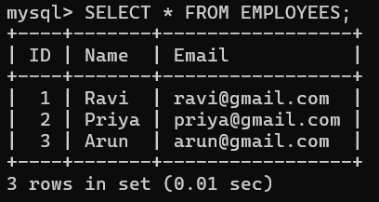
Also create a new table named EMPLOYEES_AUDIT to keep the changes of the employee table.
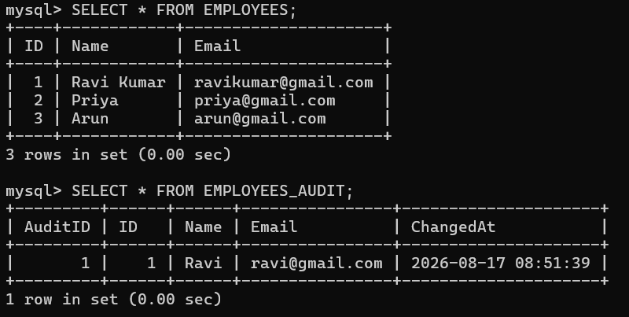
Create a BEFORE UPDATE trigger that is invoked before a change is made to the employees table.
